Module 5 Critical Thinking Assignment (Image Gallery)
Platform-Based Development
CSC475-1 Winter 2025 Session A
Mr. Farhad Bari

Grant Brosovich
12/14/2025

This application was made using JetPack Compose for the User Interface development. It allows the interface to be described declaritively and automatically react to state changes derived from the ViewModel. Material Desgin 3 components were used alongside standard material components for consistent and accessible user experiences. The different arhitecture compoinents were divided by each portion’s responsibilities. Such as, data or repository, managed by the ‘data’ package within the project, state managed by the ‘viewmodel’ package, and finally the User Interface screens managed by the ‘interfaces’ package.
The Runtime Permissions handling is being managed within the ‘interfaces’ package as well because the applicatuon is built to display this unique screen upon application start. This application uses Accompanist Permissions library to make permissions and access simple while still remaing compliant with Android 13+ media access rules. Image handling is achieved thorugh coil, which is a kotlin-first image loading library that is easily integratable and straightforward to use with Compose (Android Developers, 2025). Coil can be used to load online images using HTTP URLs as well as leverage MediaStore, as done in the application, to load local images without requiring separate logic (Google Developers Training Team, 2024). Media Store API is a modern and secure method to read shared media under the scope of Android’s storage model.
Performance optimization is achieved through usage of Material 3 components like LazyVerticalGrid to only compose and render images currently visible on the sceen. This saves tons of rendering resources and efficiently handles available images. The loading workload is handled via Coil to perform caching and decoding to prevent UI freezing and Coil also helps to ensure images are loaded only when revisited. Much of the error handling is meant to prevent freezes and crashes while also allowing for graceful degradation in the case of missing permissions or empty media libraries. Though, I think the application may be hard pressed to find a device without some local media content.
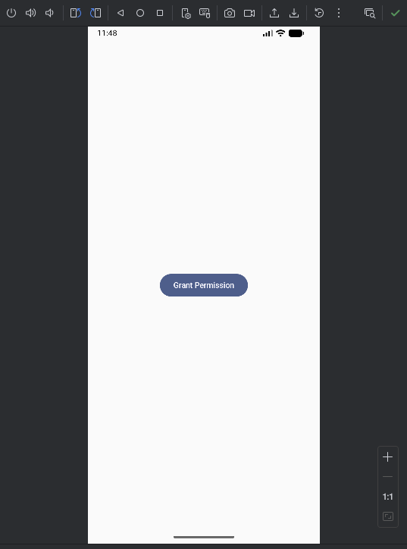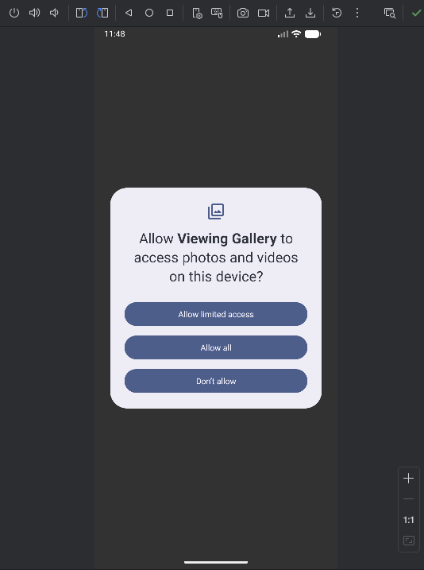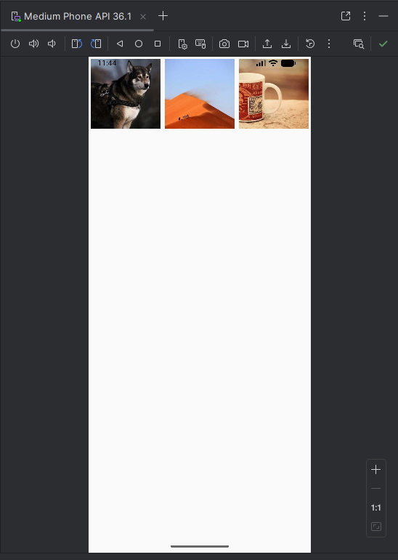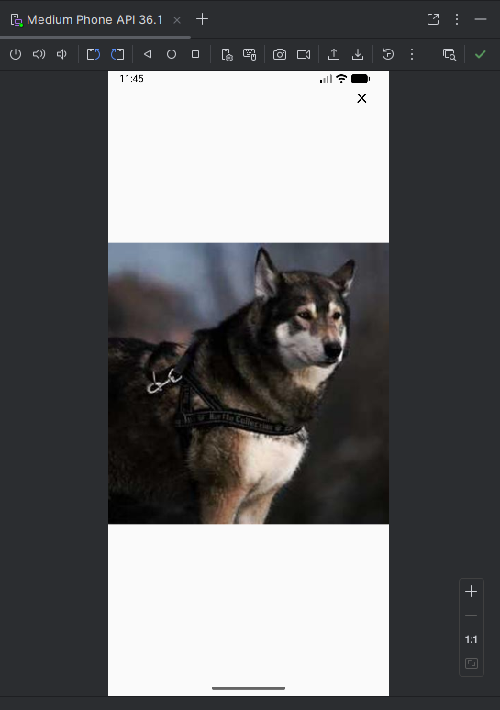
References:
Google Developers Training Team. (2024, February 1). Load and display images from the internet : android developers. Android Developers. https://developer.android.com/codelabs/basic-android-kotlin-compose-load-images#0
Load and display images : Jetpack Compose : android developers. Android Developers. (2025, December 4). https://developer.android.com/develop/ui/compose/quick-guides/content/load-images?utm_source=chatgpt.com

